Konstantinos Fotios Papadakis / AEM: 10371

Bidirectional transmission of impulses between biological systems and electronic systems to achieve Virtual Reality

Virtual reality is an upcoming rapidly-advancing technology that has passed through many stages hoping to get closer to the end goal, Full Immersion Virtual Reality (FIVR). F.I.V.R. is a theoretical, very advanced stage of VR the technologies of which are currently being researched on. This degree of immersion can happen in two ways; through the development of a B.C.I. (Brain computer interface) which entails being able to decipher neural impulses, such as volition of movement, but also transmit electrical impulses in order to artificially create all five senses or through the mixed usage of technologies that have direct connection with brain activity and technologies that utilize our existing sensory organs to simulate the stimulus that would produce such a neural impulse in the first place. This assignment will focus on the first way of achieving F.I.V.R. and to be exact, mainly on the process of artificially creating electronic neural impulses to produce all the senses of a human subject.

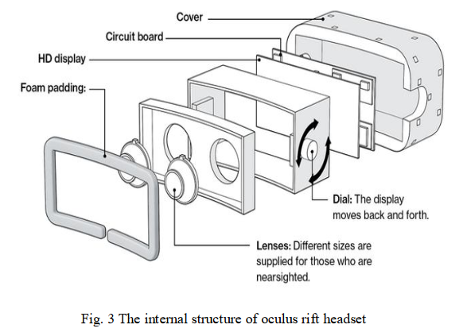
Before diving into the main topic of the paper there will be a short overview of the intermediate technologies that have risen into existence in the past years and don’t fully commit to the idea of immersion but also make substantial steps towards that ultimate goal.

The way we have been perceiving the virtual world so far is mainly through our own sensory organs and artificially created stimuli through which we try to emulate their real counterparts, as closely as we can.
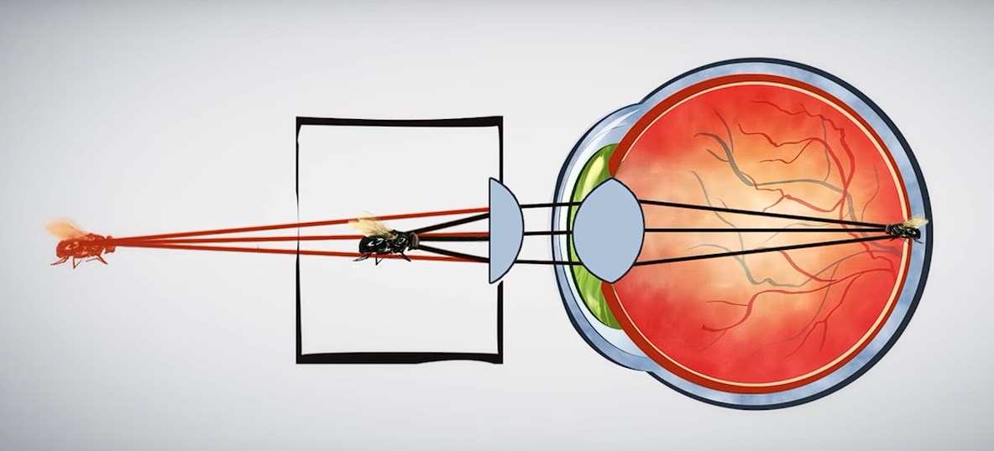
Sight is achieved via goggles that have high per-eye resolution to accomplish higher level immersion. In order to gain access to the HD display the subject’s vision has to pass through lenses that incorporate the medical prescription the wearer needs to be able to see clearly but also a technology where the light angle emitted by the display is corrected to make objects appear further away. Were it not for this implementation the display would be way too close for someone to be able to focus on it. Some manufacturers use fresnel lenses in order to cut down on weight and volume.

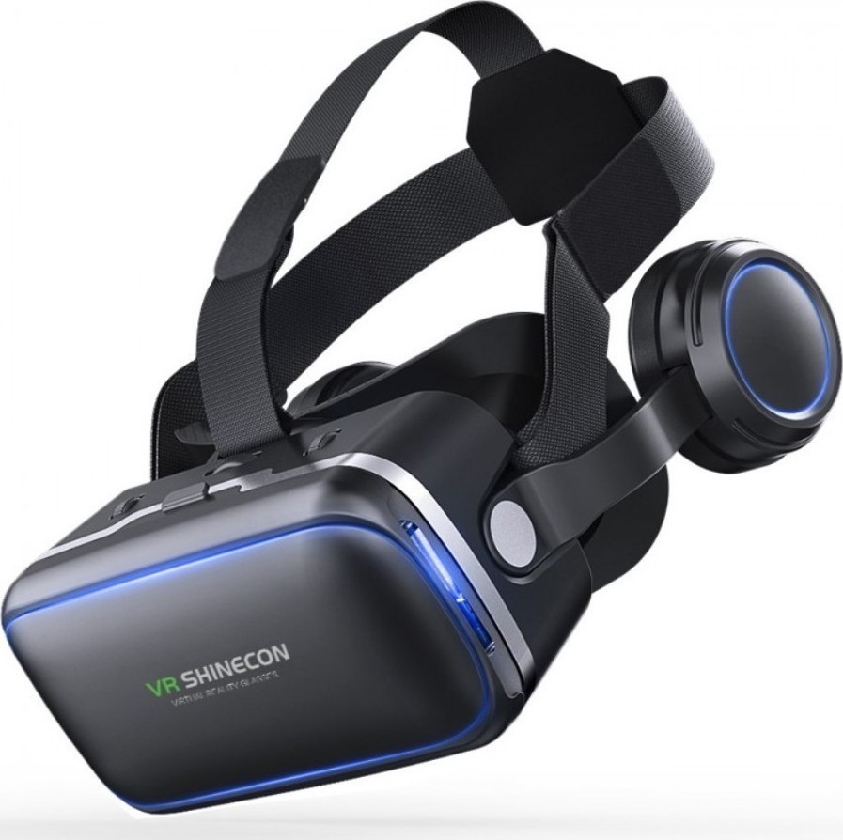
Hearing is done with the use of headphones integrated to the VR goggles themselves or not.

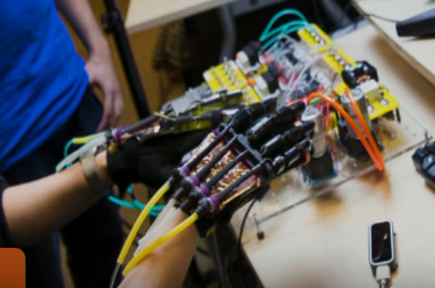
Touch and tactile sensations of the body have been incorporated to the experience through haptic armbands and full body suits that use tiny speakers/haptic motors embedded inside them in order to send vibrations on the skin.

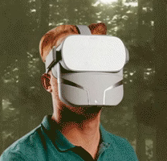
Smell is materialized through aroma-capsules inside an extension of VR headsets patented by Unreal Inc. They came up with a multisensory device called Feelreal which other than smell can also simulate wind via small fans, fire via small heaters, rain and water by emitting water mist, and creates vibration in an attempt to make VR more immersive.

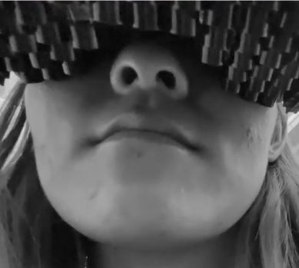
Taste hasn’t become integrated into commercial VR headsets yet, though technology that allows people to feel and taste things has been successful. For example Future Interfaces Group has developed a thin, compact, beamforming array of ultrasonic transducers (devices that convert various physical quantities, such as pressure, into an electrical signal), which can render haptic effects onto the mouth. In terms of actually tasting an electrode has been developed by the National University of Singapore which can administer electrical current and slight changes of temperature to simulate the basic tastes; saltiness, sourness, bitterness, and sweetness. Finally the last part of the puzzle, to make all this setup functional, is motion tracking.

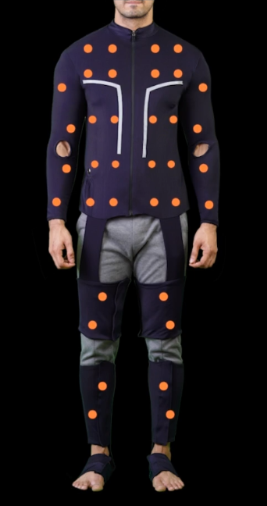
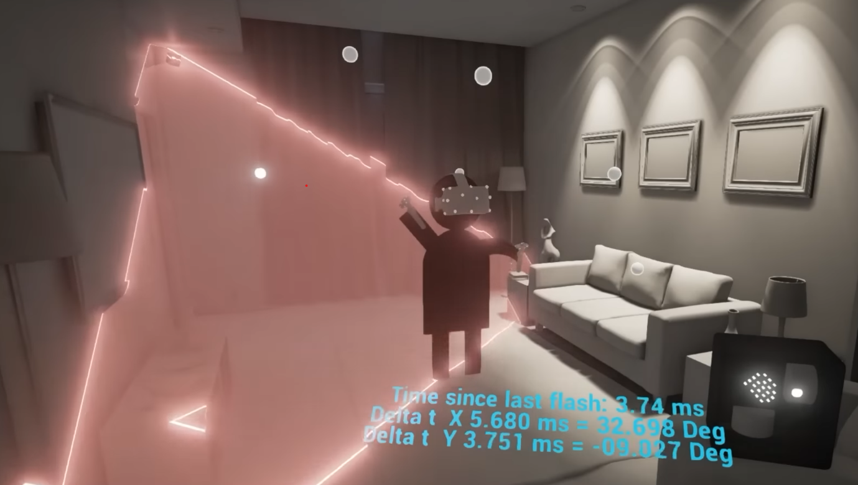
Motion is the way we are able to interact with the environment. Even though it is not one of the five senses it is inseparable from the end result and closely related to touch. The main methods of tracking the dimensions and movement of the subject to place it accurately in cyberspace are lighthouse based F.B.T.(full-body tracking) and I.M.U.(Inertial Measurement Unit) based F.B.T.. Lighthouse based F.B.T. rely on devices(stations) spread around one’s space that send out infrared signals that get picked up by each one of the sensors. Then the location of those sensors gets triangulated providing accurate positioning data. Common tracking sensors are the controllers of the VR headset, the VR headset itself and three more sensors placed on each foot and on the waist. The more sensors involved are the better the tracking is, though those 6 tracking points are considered the baseline of full-body tracking. On the other hand, I.M.U. tracking is utilizing users’ self-inputted dimensions and positional data to be able to detect, via the use of two types of sensors; accelerometers and gyroscopes, acceleration and angular velocity of the I.M.U. device. Some companies have integrated full-body tracking through I.M.U.s and haptics in the same suit. For example a team called shockwave has created a Full-body Tracking and Haptic suit which is a VR suit equipped with 12 trackers for full-body tracking and 72 haptic points. Lastly something that should be noted is that this aforementioned body tracking cannot fully provide you freedom of movement because your body is still in a confined space ultimately relying on directional buttons on the VR controllers to move towards something. To solve this problem there have been created omnidirectional treadmills that also allow you to move and transfer this mobility data to the virtual world.
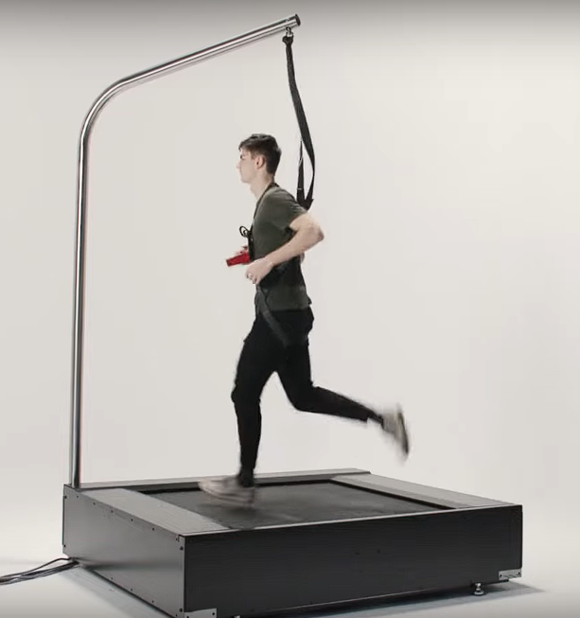
So far, this overview of the commercialized VR technology has been a glimpse of an era of virtual or augmented reality standardization in fields such as medicine, IT, business, recreation etc. A new way of enriching our reality either by creating a whole new world (VR) or a layer on top of our world (AR). A way to upgrade our means of interacting with reality and unlock humanity’s potential to materialize its ideas and broaden its influence. Upnext we are going to set foot on the most recent researched, or implemented on a small scale, projects that challenge the idea of immersion and truly revolutionize the VR technology branch. These technologies revolve around establishing a connection between the brain and the computer (B.C.I.) enabling bidirectional transfer of data. Let’s first talk about non-invasive BCI.
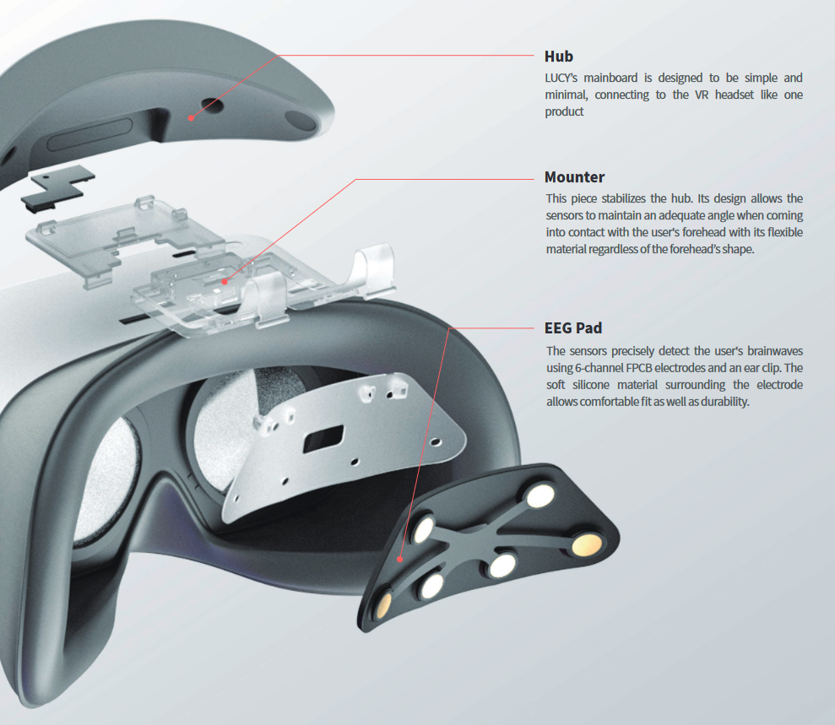
One step towards the right direction can be considered the project Looxid labs have been working on. They developed a wireless VR headset called LUCY which helps elderly people monitor their mental wellbeing and prevent decline. This feat is possible through the utilization of an EEG sensor mounted to be in contact with the forehead. This allows for the six EEG sensors to measure the prefrontal lobe’s brain waves which are closely related to cognitive abilities such as information collection and judgment. This device provides professional caretakers and welfare facilities the tools to assess the condition of elderly people and, also , train them in areas such as working memory, attention, spatial memory and overall cognitive ability.

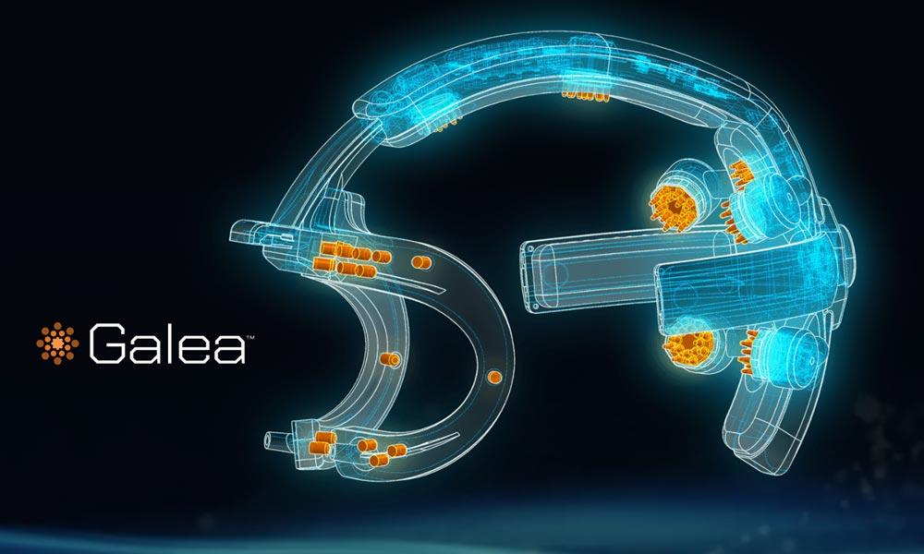
Another more intricate device is Galea, able to process multimodal signals and measure the physiological response of the person experiencing VR content. Galea’s hardware architecture can be simplified in three main blocks. 1.The digital signals block is in charge of its own wireless communication as well as the communication with the other sensing blocks. 2.The analog sensing block is tasked with collecting data from the brain (Electroencephalogram, EEG), muscles (Electromyogram, EMG) and eyes (Electrooculogram, EOG), and includes an opto-isolated section that collects data based on the electrical conductance of the skin as an immediate outcome of sweat secretion (ElectroDermal Activity, or EDA). 3.Finally the third or sensing touch-points block utilizes a flexible Printed Circuit Board (PCB) with gold-plated pickup electrodes, also called as the ergo-electronics face-pad), that is able to connect to electrodes like Ag/AgCl (silver/silver chloride), or conductive polymers. This flexible PCB also establishes a connection with the optical digital sensing sub-block which detects blood volume changes in the microvascular bed of tissue and skin temperature (Photoplethysmography, PPG).
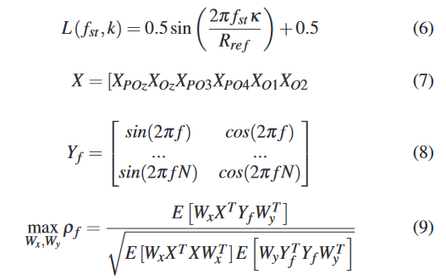
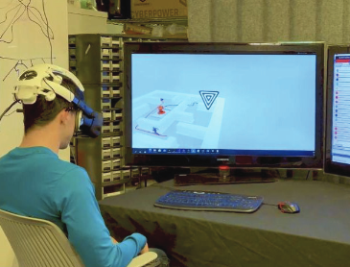
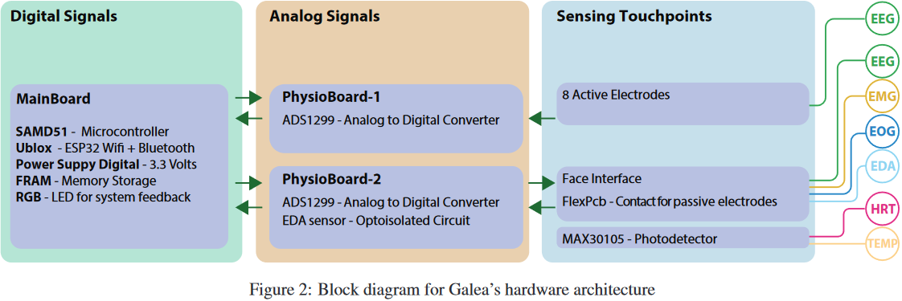
This set of sensors are used to map the various types of activity that can be observed inside and on the surface of the human head and by correctly deciphering them we can broaden the way we, as the users, interact with the VR world. This approach of hyper sensitive hardware towards our facial movements is one of the many ideas that are currently under development under the premise of providing a means of interaction with the VR that feels effortless and heightens our sense of immersion. Other companies have been focusing on capturing micromovements of our fingers that through the standardization of some gestures can allow us to use a phone-like navigation system but this time on a three dimensional VR space. The more ambitious and arguably more immersive is definitely the one Galea is trying to approach. Here is how they are trying to make this happen; BCI systems many times rely on recognizing specific brain activities, the most exemplary of which being motor imagery and steady-state visually evoked potential (SSVEP). Specifically, SSVEP is considered to be one of the most broadly used brain responses for developing BCI-based interactions. SSVEP occurs when the user of the VR headset is stimulated by a visual stimulus that has a specific frequency. They developed a VR maze game, as shown in the image on the right, in which the user is able to control an avatar using real-time biofeedback. The SSVEP game mechanics work by utilizing the user’s voluntary engagement to look at checkerboard patterns all over the maze flickering at different frequencies, which are produced using a sampled sinusoidal stimulation method. The EEG response provoked by these stimuli is analyzed using a Canonical Correlation Analysis (CCA) based algorithm. CCA computes the correlation between the EEG signal, represented in Equation 7 where X is N samples by 6 channels, and the expected stimulus frequency, represented in Equation 8 where Yf is a sinusoid of frequency f and N samples. Then, based on the canonical correlation Equation 9, the frequency f which produces maximum correlation ρf is picked as the SSVEP prediction. This allows the user to move the avatar to different designated locations in the maze.

The use of BCI in Galea has showcased to some extent the degree of our advancements in non-invasive BCIs. In order to acquire less noisy information we have to go one step further and set foot on partially invasive BCI. The structure of the skull is such that it interferes with our readings dampening the signals when having to communicate with the brain from outside the skull. Thus it only makes sense to incorporate the sensors inside the skull.

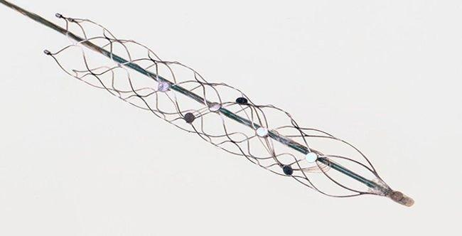
One of the two main ways to establish this communication is by inserting a cylindrical mesh of electrodes inside the walls of the veins (Endovascular). The mesh, also called Stentrode, gets delivered through an intravenous catheter being guided along the way, by image feedback from a fluoroscope, to the superior sagittal sinus which is a midline vein that drains many cerebral structures surrounding it and neighbors the motor cortex. This proximity enables the electrodes and the sensors to measure neural activity. The Stentrode passes on the neural activity to a batteryless telemetry unit which is implanted in the chest of the patient passing on the information it collects wirelessly to an external telemetry device capable of power and data delivery. This method has the benefit of minimizing dangers such as clottings and venous thrombosis that come with craniotomy by utilizing a different path inside the brain which is arguably more protected and less likely to deteriorate over time. This device has been used in order to enable 5 people with amyotrophic lateral sclerosis and primary lateral sclerosis to wirelessly control an operating system via which they could text, email, shop, and bank using direct thought.
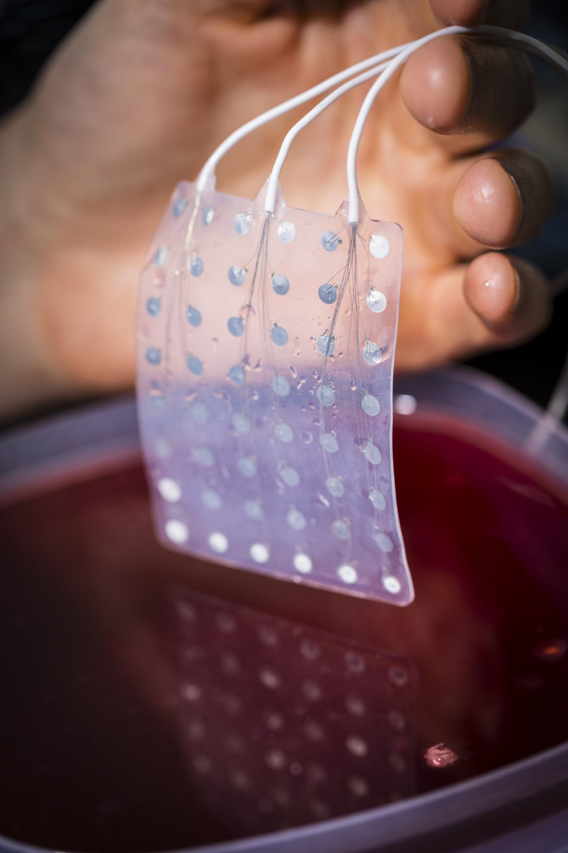
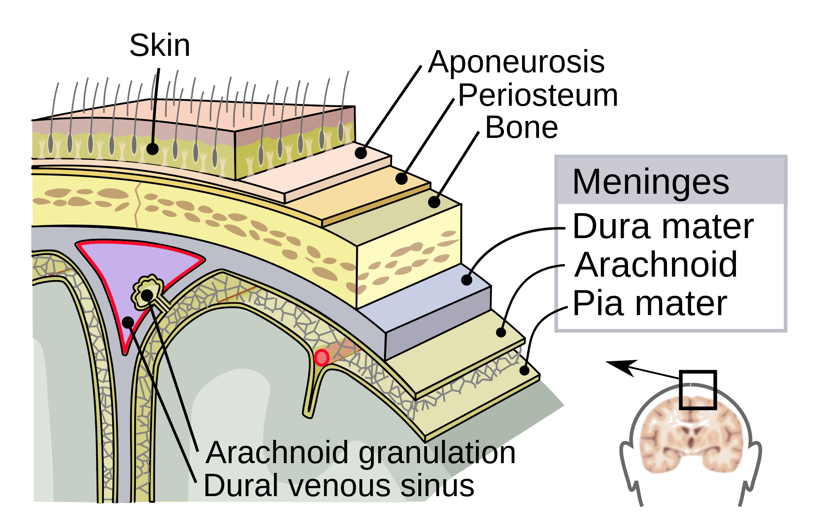
The second method of communicating with the brain is via Electrocorticography. ECoG, for short, succeeds in acquiring brain electrical activity data by using electrodes embedded in a thin plastic pad that is placed above the cortex and below the dura mater. The learning curve of getting used to the device is a lot steeper than the non-invasive BCIs we mentioned earlier because getting used to it is a lot more intuitive. An example of a successful trial on the ECoG technology is the instance when a teenage boy was rendered able to play the game “Space Invaders” with just his thoughts. Eric C. Leuthardt, M.D., an assistant professor of neurological surgery, and Daniel Moran, Ph.D., assistant professor of biomedical engineering, performed their research on spotting and removing the specific region or regions of the brain where the abnormal electrical discharges that cause seizures originate. Overall ECoG is very promising since it has higher spatial resolution, better signal-to-noise ratio, wider frequency range, and less training requirements than scalp -recorded EEG, but also simultaneously it has lower technical difficulty and lower clinical risk.
Finally we have invasive BCI which, as is evident, includes implanting electrodes under the scalp ending up producing very clear to interpret data but not without adverse effects. This technology could possibly stimulate the production of scar tissue which could engulf the sensors and make the signals hard to send or receive depending on the specific use, not to mention the possibility of the body completely rejecting the implanted device.
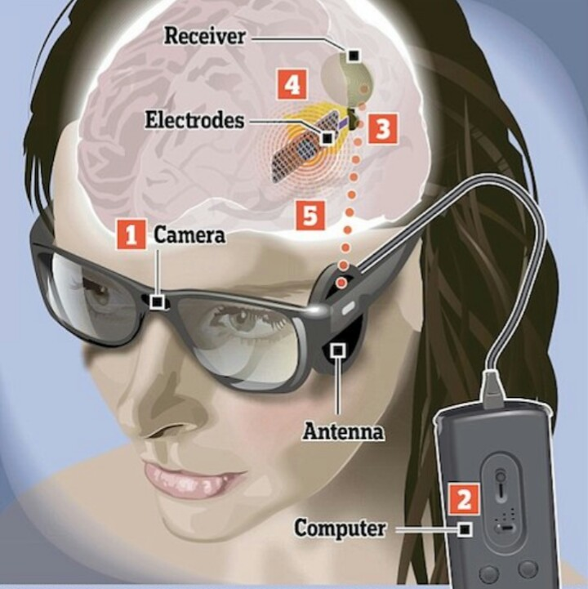
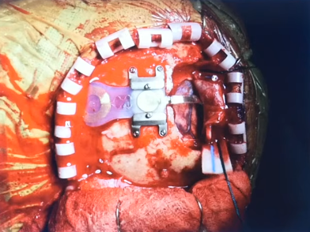
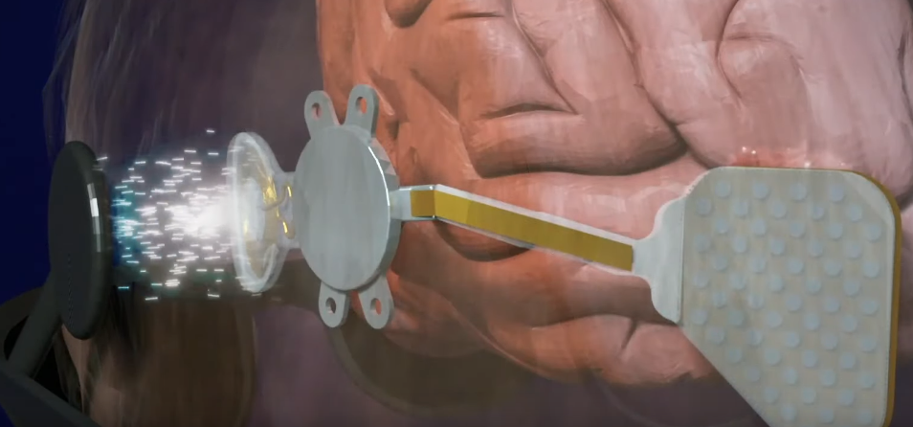
One of the uses invasive BCI has seen these years is restoration of vision in people diagnosed with blindness. This procedure requires the people that undergo it to have a functional vision cortex so most of the time it is used on people with non-congenital blindness. The device is called Orion and it was created by Second Sight Medical Products, Inc.. As we speak Second Sight has acquired FDA approval and they have been testing the implant with the help of five subjects. The two-year results from the study published in May of 2021 showed positive results with five out of five people being able to locate a white square of a dark computer screen and four out of five being able to better identify the direction of motion of a bar moving across the screen. The device works by bypassing the injured eye’s anatomy transmitting electrical impulses directly to an array of electrodes implanted on the brain’s visual cortex. Orion’s hardware comprises a pair of glasses which feature a camera on front to capture visual data, a video processing unit in which the signals from the camera are being directed towards (this unit can be configured by the patient using the sliders to tweak the contrast, brightness and zoom). After the signal is processed it gets sent back up through the cable to the transmitting antenna. The antenna then transmits the video signal to the brain implant meanwhile power also gets provided via two coils on each side of the transmission (glasses-implant). Then the information gets decoded by the permitting package ultimately providing a stimulation of the electrode array which is placed between the two hemispheres on the visual cortex.
One of the adverse effect of the clinical trials was a seizure one of the patients had which was caused by
an overstimulation of the visual cortex.

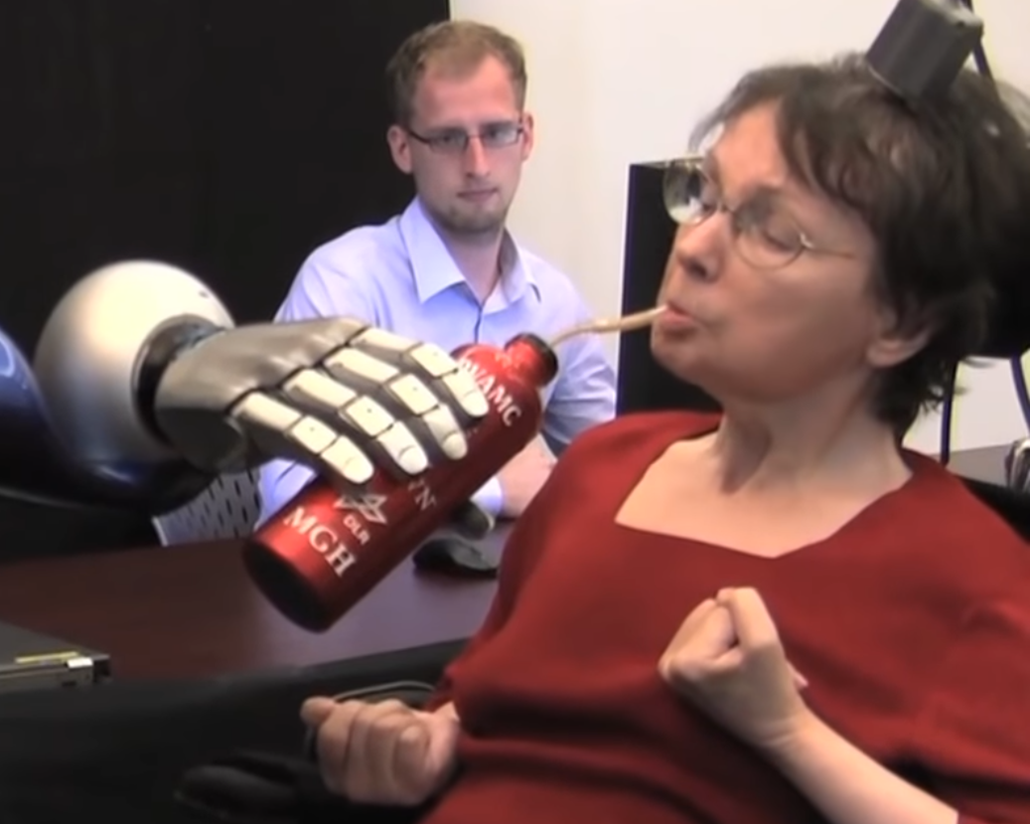
Another great achievement of invasive BCI technologies has been neuroprosthetics and in particular restoring movement on patients that have at some point in their lives had a stroke deeming them unable to move or even paralysis induced by any possible factor. The device used to restore the patient's mobility is called BrainGate. The way it works is by deciphering signals, via a 96-electrode sensor, coming from a brain implant located at the right precentral gyrus which is anatomically the area of the motor cortex responsible for arm movement. These impulses coming from the brain then get translated through an external computation device into a command for the robotic/ prosthetic arm. BrainGate has demonstrated further success in direct control of robotic prosthetic limbs with many degrees of freedom using direct connections to arrays of neurons in the motor cortex of patients with tetraplegia.

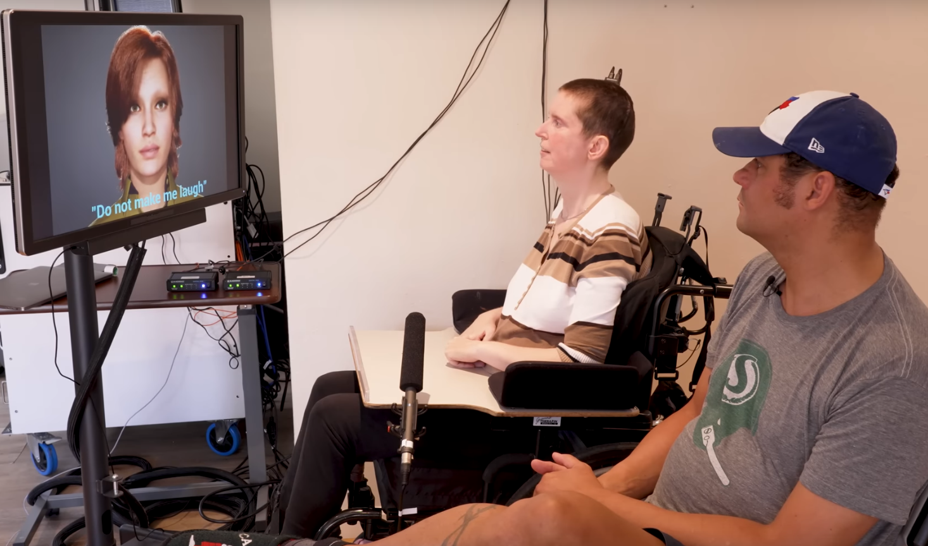
The last invasive BCI project we are going to be analyzing is the novel attempt at artificially reconstructing the voice of people that lost the ability to speak due to causes such as stroke or ALS. The device is picking up the neural activity related to moving facial muscles and turns that into speech. The signals originate from signals acquired from a high-density electrocorticography (ECoG) array implanted over the sensorimotor cortex. The picture on the left depicts Ann who suffered a brainstem stroke leaving her severely paralyzed. This system has enabled her to recreate her speech at a speed of text approximately 78 words per minute. This was made possible by deep-learning models using neural data collected as the participant attempted to silently speak sentences.

So what is the future of BCI technology and what is the connection between advanced BCI technology and F.I.V.R.?

To explore the new possibilities we will have to examine Elon Musk’s company Neuralink which recently got approved from the FDA to start human testing and also has showcased some interesting results in animal testing. Neuralink doesn’t propose new things. It is a collection of already researched projects formed into a brand name that has a lot of financial backing in the form of Elon Musk. The BCI Neuralink intends to release is focused on giving people with quadriplegia the ability to operate their computers with their thoughts and for the future they express in their site their dream of: “In the future, we hope to restore capabilities such as vision, motor function, and speech, and eventually expand how we experience the world.”. As we have previously stated, all of these capabilities are not something new. The aspect of it that is truly new is the generalized nature of this technology, aiming to be versatile and applicable to a broad range of conditions or disabilities, and the discrete nature of the design, having no external cables or computation devices rendering it a lot more normal and smoothly integrated to our human bodies than any other past research projects. Also there is a computational device involved in this BCI but it is a smartphone which we already carry with us in our day to day lives. Here is an example of vision restoration with Neuralink:
Finally one last really impressive feat Neuralink wishes to achieve is integrating 16.000 electrodes inside the new version of the implant which compared to all of the projects so far will provide us with an infinitely larger scale of data deciphering from the brain and transmission to the brain.

It seems our technology thus far is mainly capable of transcribing someone’s will by detecting and analyzing their physiological changes which is considered to be one of the two directions information in a BCI system can go. Apart from further advancing of the already existing types of technologies we expect projects to ramp up the complexity by exploring the transmission of electronic neural impulses, this time, from the computer to the brain which has already happened to an extent as we saw in the case of Orion. The slow progression computer to brain signaling is experiencing is due to the bioethical arguments of the adverse effect harmful signals have manifest when interpreted by the brain. There is always the possibility of developing short-term or/and long term consequences as seen in the seizures from the vision restoration project. This means that virtual reality will most likely refrain from tapping into invasive neurological procedures because this technology hasn’t been tested enough, the idea of routine surgical operations is a unfamiliar idea making the public very cautious and less likely to undergo such an operation but most importantly the end result of the equipment that is used so far to submerge people in the virtual world are far more capable and feel a lot more familiar to the way we perceive reality through our biological means. BCI technologies will probably be used as a means to help disabled individuals regain their lost functionality to the best of our abilities and when the technologies advance enough to be considered safe, routine operations and their ability to emulate the biological senses adequately, only then, will we start equipping ourselves with such machinery as a means to improve our productivity and advance our scope of capabilities.
Bibliography
Full Immersion Virtual Reality - At the Edge of Reality and Fantasy
Prashant Kumar
TEDxIEMadrid 2019
https://www.youtube.com/watch?v=pJxZUqJqn6c
I’ve Tried A Future Of Brain-Connected VR
CNET
6/7/2023
https://www.youtube.com/watch?v=uhLxggasiqE
Αrtificial sense technology: emulating and extending biological senses
Jianwu Wang, Cong Wang, Pingqiang Cai, Yifei Luo, Zequn Cui, Xian Jun Loh, and Xiaodong Chen
12/7/2021
https://doi.org/10.1021/acsnano.1c10313
Bioinspired multisensory neural network with crossmodal integration and recognition
Tan, H., Zhou, Y., Tao, Q. et al. Bioinspired multisensory neural network with crossmodal integration and recognition. Nat Commun 12, 1120 (2021).
https://doi.org/10.1038/s41467-021-21404-z
A Review Paper on Oculus Rift-A Virtual Reality Headset
Parth Rajesh Desai, Pooja Nikhil Desai, Komal Deepak Ajmera, Khushbu Mehta
International Journal of Engineering Trends and Technology (IJETT) – Volume 13 Number 4 – July 2014
https://doi.org/10.48550/arXiv.1408.1173
How Lenses for Virtual Reality Headsets Work
VR Cover
9/5/2016
https://www.youtube.com/watch?v=NCBEYaC876A
Feelreal - The World's First Multisensory VR Mask
Unreal, Inc.
https://www.indiegogo.com/projects/feelreal-the-world-s-first-multisensory-vr-mask--2#/
Mouth Haptics in VR using a Headset Ultrasound Phased Array
Vivian Shen, Craig Shultz, Chris Harrison
29/4/2022
https://doi.org/10.1145/3491102.3501960
FIVR
Paulo Pacheco, Neo222, Shadowdawn
Last update 28/9/2022‎
https://xinreality.com/wiki/FIVR
A 3D-Printed, Adjustable Armband for Electromyography-Based Finger Movement
Classification With Haptic Feedback
Michelle Wang, Miasya Bulger, Yue Dai, Kira No¨el, Christopher Axon, Anna Brandenberger, Stephen Fay, Zeng Hao Gao, Saskia Gilmer, Jad Hamdan, Prateek Humane, Jennifer Jiang, Cole Killian, Ian Langleben, Bonnie Li, Alejandra Martinez Zamora, Stylianos Mavromatis, Sasha Njini, Roland Riachi, Carrie Rong, Andy Zhen, Marley Xiong
14/12/2020
https://doi.org/10.1109/SMC42975.2020.9283117
Virtual ingredients for food and beverages to create immersive taste experiences
Ranasinghe, N., Lee, KY., Suthokumar, G. et al. Virtual ingredients for food and beverages to create immersive taste experiences. Multimed Tools Appl 75, 12291–12309 (2016).
06/1/2016
https://doi.org/10.1007/s11042-015-3162-8
HTC Vive Lighthouse Chaperone tracking system Explained
rvdm88
25/8/2015
https://www.youtube.com/watch?v=J54dotTt7k0
A Review of Accelerometer Sensor and Gyroscope Sensor in IMU
Sensors on Motion Capture
Ilham Arun Faisal, Tito Waluyo Purboyo and Anton Siswo Raharjo Ansori
Journal of Engineering and Applied Sciences 15 (3): 826-829, 2020
ISSN: 1816-949X
© Medwell Journals, 2020
https://doi.org/10.36478/jeasci.2020.826.829
Omnidirectional treadmill CM1 - running in Virtual Reality - work in progress 2
ACTVR
29/11/2021
https://www.youtube.com/watch?v=R-bWKF6ySTo
Brain–computer interface
https://en.wikipedia.org/wiki/Brain%E2%80%93computer_interface#Human_BCI_research
Advances in Intelligent Systems and Computing
Editors: Wojciech P. Hunek, Szczepan Paszkiel
https://doi.org/10.1007/978-3-319-75025-5
Wearable Brain-Computer Interfaces
Pasquale Arpaia, Antonio Esposito, Ludovica Gargiulo, Nicola Moccaldi
https://doi.org/10.1201/9781003263876
Brain-Computer Interfaces for Human Augmentation
Riccardo Poli, Davide Valeriani, Caterina Cinel
ISBN 978-3-03921-906-3 (Pbk)
ISBN 978-3-03921-907-0 (PDF)
https://www.mdpi.com/journal/brainsci/special_issues/Brain_Computer_Interface
Deep Learning for EEG-Based Brain-Computer Interfaces
Xiang Zhang, Lina Yao
ISBN 9781786349590 (ebook) | ISBN 9781786349606 (ebook other)
https://lccn.loc.gov/2021024493
Brain–Computer Interfaces Handbook
Chang S. Nam, Anton Nijholt, Fabien Lotte
https://lccn.loc.gov/2017035052
OpenBCI Galea Drone Flight Overhead
24/4/2023
https://www.youtube.com/watch?v=2xBNpotE4aI
Galea: A physiological sensing system for behavioral research in
Virtual Environments
Guillermo Bernal, Nelson Hidalgo, Conor Russomanno, Pattie Maes
https://doi.org/10.1109/VR51125.2022.00024
Lucy
Looxidlabs
https://looxidlabs.com/product/all
Stentrode brain computer interface online in first two human patients
Synchron Inc
28/10/2020
https://www.youtube.com/watch?v=mm95r05hui0
Opie, N. (2021). The Stentrode TM Neural Interface System. In: Guger, C., Allison, B.Z., Tangermann, M. (eds) Brain-Computer Interface Research. SpringerBriefs in Electrical and Computer Engineering. Springer, Cham.
https://doi.org/10.1007/978-3-030-60460-8_13
This machine creates artificial vision for the blind
CNET
6/9/2019
https://www.youtube.com/watch?v=DxzcR3mZa3U
Second Sight to Accelerate Development of Orion Visual Cortical Prosthesis System
Second Sight Medical Products
05.16.2019
https://eyewire.news/articles/second-sight-to-accelerate-development-of-orion-visual-cortical-prosthesis-system/?c4src=article:infinite-scroll
Second Sight Medical Products Announces Two-Year Results of its Orion Study
12/5/2021
https://www.businesswire.com/news/home/20210512005147/en/Second-Sight-Medical-Products-Announces-Two-Year-Results-of-its-Orion-Study
Thought control of robotic arms using the BrainGate system
NIH NINDS
16/5/2012
https://www.youtube.com/watch?v=QRt8QCx3BCo
How a Brain Implant and A.I. Gave a Woman with Paralysis Her Voice Back
UC San Francisco (UCSF)
23/8/2023
https://www.youtube.com/watch?v=iTZ2N-HJbwA
Generalizable spelling using a speech neuroprosthesis in an individual with severe limb and vocal paralysis
Metzger, S.L., Liu, J.R., Moses, D.A. et al.. Nat Commun 13, 6510 (2022).
https://doi.org/10.1038/s41467-022-33611-3
A high-performance neuroprosthesis for speech decoding and avatar control
Metzger, S.L., Littlejohn, K.T., Silva, A.B. et al.
Nature 620, 1037–1046 (2023).
https://doi.org/10.1038/s41586-023-06443-4

